

Software Engineering
Test Plan Document:
Iteration 1

Philip M. Knouff
Gerald I. Ottman III
Michael D. Bristol
William D. Whelchel II
Randy B. Akers
Radford University
Department of Information Technology
https://php.radford.edu~/softeng12

Revisions

Version | Primary Author(s) | Description of Version | Date Completed
3.0 | William Whelchel | Status of tests in Iteration 1 for each user story created for Iteration 1. | 02/014/2012

Review & Approval
Test Plan Document Approval History
Approving Party | Version Approved | Signature | Date
Dr. T. L. Lewis | 3.0
Customer | 3.0

Iteration Document Review History
Reviewer | Version Reviewed | Signature | Date
Phillip M. Knouff | 3.0
William D. Whelchel II | 3.0
Randy B. Akers | 3.0
Michael D. Bristol II | 3.0
Gerald I. Ottman III | 3.0

Table of Contents
1 Introduction 4
1.1 Iteration Overview 4
1.2 Definitions and Abbreviations 4
1.3 References 4
1.4 Items Not Covered by These Test Cases 5
1.5 Bug Tracking 5
1.6 Quality Control 5
1.7 Adequacy Criterion 5
2 Test Strategy 6
2.1 Testing Process 6
2.2 Technology 6
3 Test Cases 7
4 Customer Acceptance Testing 9

Introduction

Iteration Overview
Iteration 1 will provide the client with the ability to login and logout of the system. The disclaimer indemnifying OpenHack, and its developers will be implemented. The user will be able to see a list of all instances that are candidates for Chaos. The tests will cover searching, logging in, the disclaimer, and selection of a random instance.
We will assume that the user is not attempting to forcibly break the system.

Definitions and Abbreviations
Term | Definition
Test # | Test Case Number / Identifier
Requirement | Requirement that the test cases are validating (number / identifier)
Action | Action to perform or input to produce
Expected Result | Result expected when action is complete
Actual Result | What was actually seen
P / F | Pass / Fail indicator. Checkmark = Pass. “F” = Fail
Notes | Additional notes, error messages, or other information about the test.
OpenHack | The project referred to as a whole
OpenStack | The open-source web framework the system will be designed to operate on
EC2 | The Amazon cloud framework the original ChaosMonkey application ran on
Nova | The OpenStack API the system will interface with
Python | The Language the system will be coded in
C# | The language the original ChaosMonkey application was written in
IDE | Integrated Development Environment

References
Description | Link
Original ChaosMonkey source code | https://github.com/simonmunro/ChaosMonkey
Python documentation | http://python.org/
OpenStack Documentation | http://docs.openstack.org/
VersionOne | versionone.com
Novaclient API | https://github.com/openstack/python-novaclient

Items Not Covered by These Test Cases
Everything in this iteration is being tested.

Bug Tracking
Information on bugs, including, date found, description, status, priority and unique ID, will be tracked in a spreadsheet.

Quality Control
Our test plans will be considered successful if they identify errors in specific components of our system.

Adequacy Criterion
We will use the priority of the user story to develop a scale to track the quality of our test plan.

Test Strategy

Testing Process
All of our user stories are functional requirements and we will write specific test-cases for each one.
Testing will be conducted in a top-down manner, meaning testing will conducted using black-box approach. William Whelchel will be responsible for the unit tests. Randy Akers will be responsible for the integration tests.

Technology
VersionOne
Rackspace cloud servers running OpenStack.

Test Cases
This section details for each test the exact steps necessary to perform the test and the expected results, and provides a section for recording the observed results. This table is the most important section of the document. It comprises both the plan and the results of executing the plan. That is, it is filled in by the test team as the testing process proceeds. Failed tests should result in bug reports.
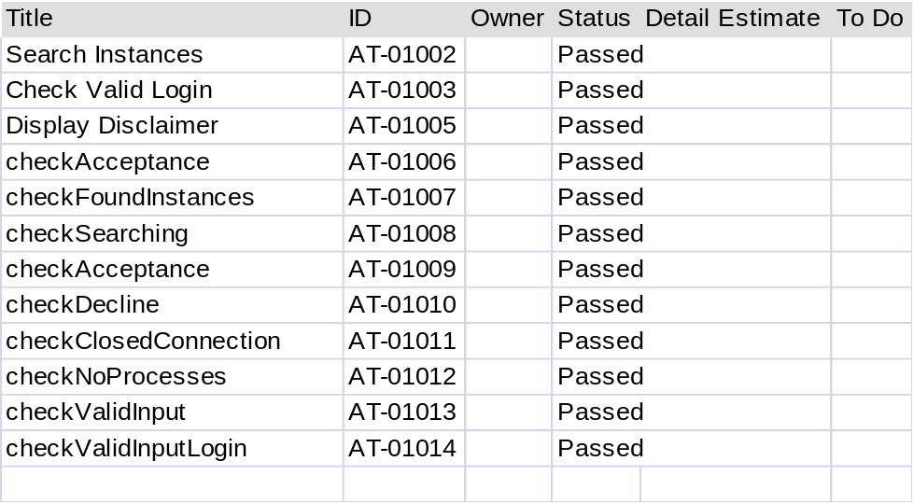

Test # | User Story | Action / Input | Expected Result | Actual Result | P/F | Notes | Date test performed | Tester
AT-01002 | Search for Instances | Python Script | Notice of found Instances | <True> | P | Python Script Tested | 2/14/2012 | Gerald Ottman
AT-01003 | Login | Python Script | Displays Disclaimer | <Warning chaos will begin> | P | Python Script Tested | 2/14/2012 | Gerald Ottman
AT-01005 | Display Warning/Disclaimer | Python Script | Read a warning of OpenHack | <Warning press D to continue> | P | Python Script Tested | 2/14/2012 | Gerald Ottman
AT-01006 | Display Warning/Disclaimer | Python Script | Disclaimer Accepted message | <Accepted Disclaimer> | P | Python Script Tested | 2/14/2012 | Gerald Ottman
AT-01007 | Display Instances Found | Python Script | Display list of Instances | <Server list> | P | Python Script Tested | 2/14/2012 | Gerald Ottman
AT-01008 | Search for Instances | Python Script | Notice of found Instances | <List of Instances found> | P | Python Script Tested | 2/14/2012 | Gerald Ottman
AT-01009 | Display Acceptance/Refusal of Disclaimer | Python Script | Disclaimer Accepted message | <accepted Disclaimer> | P | Python Script Tested | 2/14/2012 | William Whelchel
AT-010010 | Display Acceptance/Refusal of Disclaimer | Python Script | OpenHack closes | <openhack terminated > | P | Python Script Tested | 2/14/2012 | William Whelchel
AT-010011 | Terminate | Python Script | OpenHack Closes | <closed> | P | Python Script Tested | 2/14/2012 | William Whelchel
AT-010013 | Handle Disclaimer Input | Python Script | OpenHack closes | <closed> | P | Python Script Tested | 2/14/2012 | William Whelchel
AT-010014 | Handle bad input | Python Script | No Nova authentication error | No error | P | Python Script Tested | 2/14/2012 | William Whelchel

Guidelines:
- Although the information in the table above indicates that each test comprises a line, actual descriptions may require multiple lines.
- The Test # can represent a category or set of tests related to a user story. In these situations, add a suffix to the number using small Roman letter. For example, use Test 2.a, Test 2.b, …
- All tests should have a specific purpose. For example, a test may evaluate the satisfaction of a specific requirement, in which case, the user story number should be included.
- A test (Action) may comprise a series of steps. Each step should be specific with regard to relevant user input and data files. That is, the information in this document is a prescription for executing the test.
- Some steps may be common to more than one Test. Some Tests may take up where others left off. There is no need to duplicate this content. In these cases, refer in the Action section to the Test # and Step Numbers that should be performed.
- Expected Results describe the exact output that should be produced by the test. Actual Output is what happened when the test was run. Note that for non-functional tests, the contents of this field might include elapsed time, memory consumed, etc. For failing tests, the output might include information about exceptions raised.
- P/F denotes Pass / Fail. A test should only pass if its expected output matches its actual output.
- The Notes field can provide details so that the team can repeat the test in future iterations.

Customer Acceptance Testing
This section details for each test the steps necessary for the customer to perform acceptance testing and the expected results, and provides a section for recording the observed results. This table should be filled in by the customer as the testing process proceeds. Failed tests should result in bug reports.

Customer Signature: __________________________

Test # | User Story | Action / Input | Expected Result | Actual Result | P/F | Notes | Date test performed

